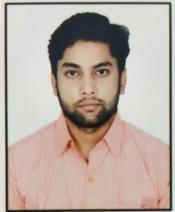
SUMIT CHANDRA
Village  Dyalkhera Post Magarwara
District – Unnao U.P (209801)
Mob- +91 9125618034, 6307592522
E-mail id – sumitchandra990@gmail.com

CAREER OBJECTIVE:

- To work in an esteemed organization where I can show my capabilities and give my complete support the improvement of the organization.

ACADEMIC QUALIFICATION

- Advance Diploma in Cloud Computing .(National Skill Training Institute, Chennai) 2019
- Graduation (B.Sc) from C.S.J.M. University Kanpur in 2018
- Intermediate from U.P. Board in 2015
- High school from U.P. Board in 2013

TECHNICAL PROFICIENCIES

- Platforms  Windows, Linux.
- Web designing  HTML, CSS, JavaScript.
- Web Development  PHP & MYSQL, MongoDB.
- Computer Networking  PAN, LAN,MAN,WAN

LANGUAGE KNOWN - Hindi & English

CERTIFICATION

- CCC form (NIELIT) National Institute of Electronics & Information Technology in 2018
- Accounts Assistant Using Tally
- Soft Skills For Base Line Steff in Service Sector

PERSONAL PROJECTS

- Online Shopping Portal - Online Shopping Portal Website Using PHP & MYSQL

